**How to Implement PAM (pluggable authentication module)**

In this document I will demonstrate how to implement PAM with Connect:Direct UNIX to authenticate external user accounts through OpenLDAP.

Note: You should install an LDAP Browser before continuing, as you will need the root Distinguished Name (DN) and user base DN to help configure your LDAP settings with the UNIX system LDAP client. In this demonstration we will be using the Apache Directory Studio LDAP Browser. Instructions on how to install and configure this browser starts on page 29 of this document.

Before we begin, let it be known that the following information came from extensive research and the configuration within is only “one” way on how to implement PAM.

For an overview of the documentation available for your product and the latest documentation updates, refer to <http://www.suse.com/doc>

The directory /etc/pam.d/ contains the PAM configuration files for each PAM-aware application. In earlier versions of PAM, the file /etc/pam.conf was used, but this file is now deprecated and is only used if the /etc/pam.d/ directory does not exist.

Each PAM-aware application or service has a file within the /etc/pam.d/ directory. Each file within this directory bears the name of the service for which it controls access.

It is up to the PAM-aware program to define its service name and install its own PAM configuration file in the /etc/pam.d/ directory. For example, the login program defines its service name as login and installs the /etc/pam.d/login PAM configuration file.

**In this example, the environment for Connect:Direct and the LDAP client is as follows:**

[root@ironman] /home/cd4104 $ **uname -a**

Linux ironman 3.0.76-0.11-default #1 SMP Fri Jun 14 08:21:43 UTC 2013 (ccab990) x86_64 x86_64 x86_64 GNU/Linux

[root@ironman] /home/cd4104 $ **cat /etc/*release**

LSB_VERSION="core-2.0-noarch:core-3.2-noarch:core-4.0-noarch:core-2.0-x86_64:core-3.2-x86_64:core-4.0-x86_64"

SUSE Linux Enterprise Server 11 (x86_64)

VERSION = 11

PATCHLEVEL = 3

IBM(R) Sterling Connect:Direct(R) for UNIX Version 4.1.0.4_iFix013, Build date 01Nov2013, Intel x86

Linux

Note: Connect:Direct is a 32bit application!

**Verify you have the 32bit packages installed for pam and ldap client:**

[root@ironman] /home/cd4104 $ rpm -qa |grep ldap-32

nss_ldap-32bit-262-11.32.37.1

pam_ldap-32bit-184-147.20

[root@ironman] /home/cd4104 $ rpm -qa |grep pam-32bit

pam-32bit-1.1.5-0.10.17

I highly recommend using YaST Control Center for ease in searching and installing the packages.

Make sure you have an X-Windows service running before bringing up the YaST Control Center!

[root@ironman] /home/cd4104 $ yast2

Click on **Add-On Products** under the **Software Group**

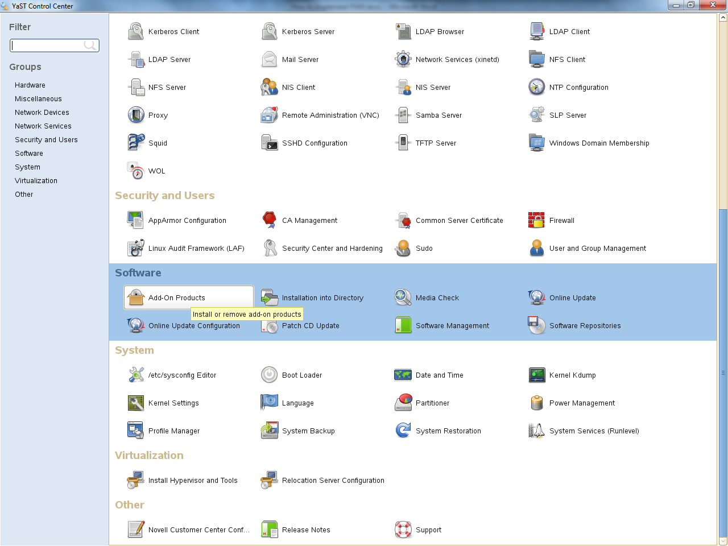

Click on **Run Software Manager**

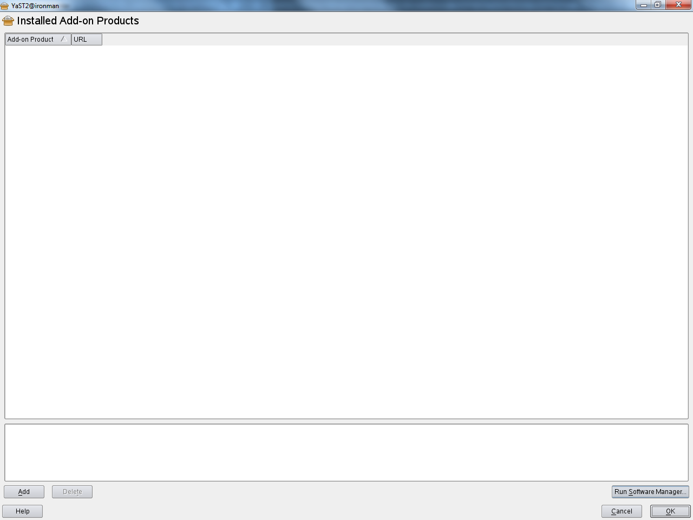

Click on the **Search Tab** and enter the package name **ldap-32,** then hit enter to display

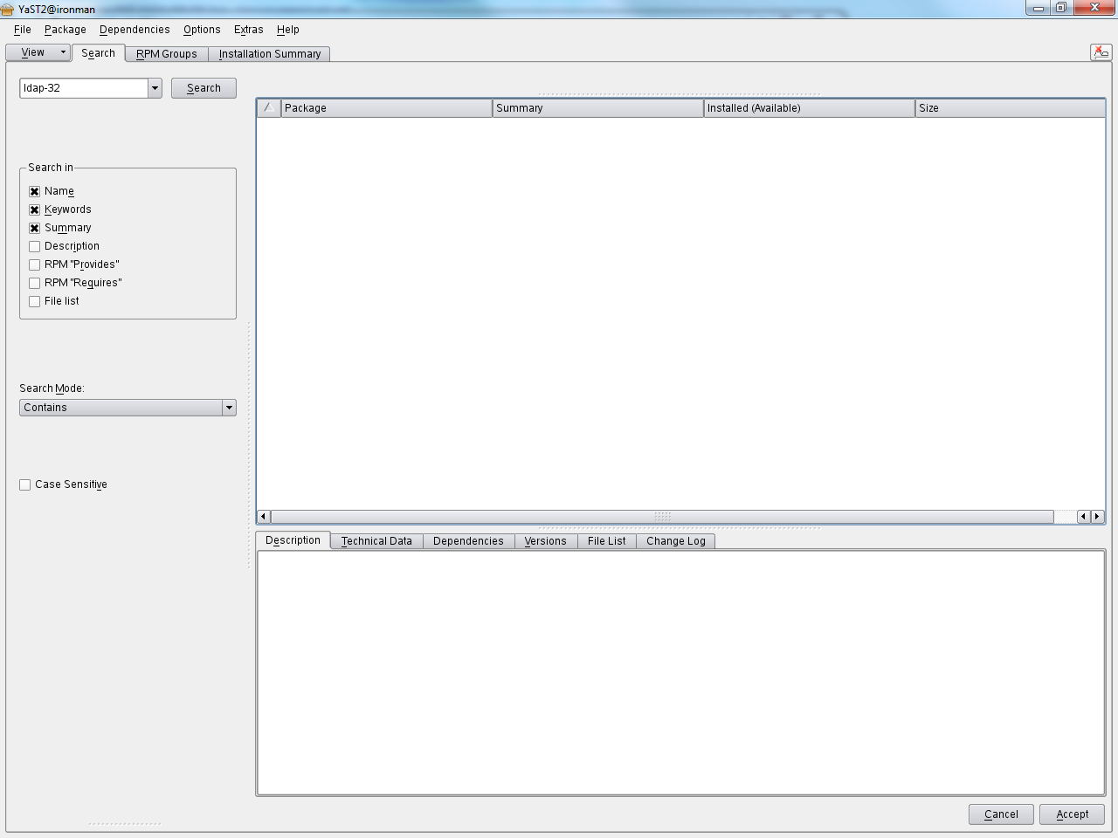

Check each box next to the package to install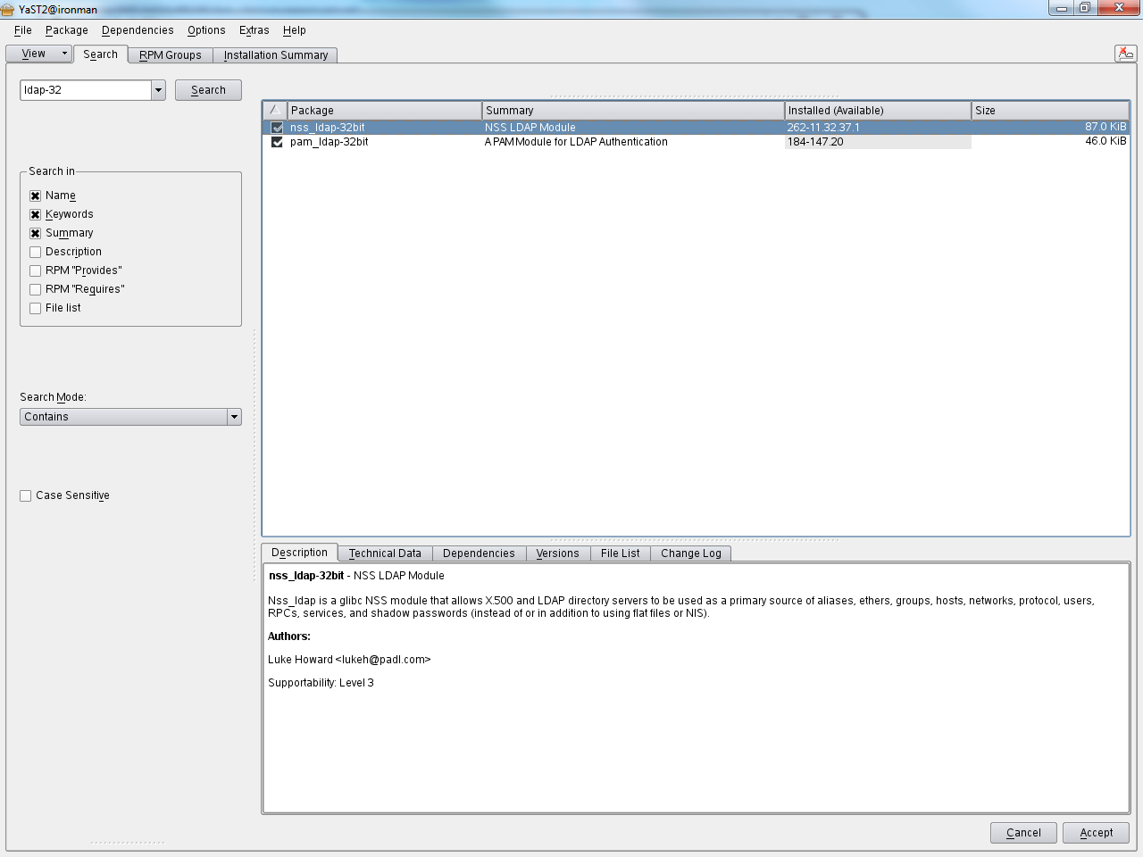

Note: If the box already has a check mark then the packages are already installed and you can continue to the next step.

Perform the same procedure for the **pam-32** packages

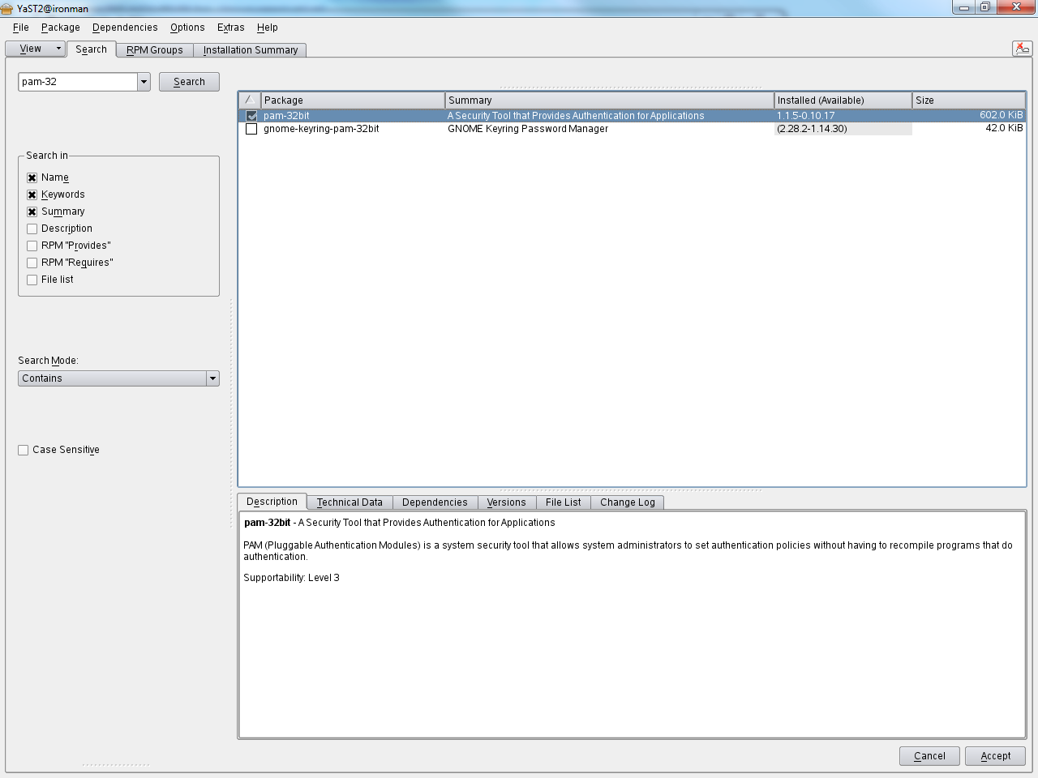

Note: If the box already has a check mark then the packages are already installed and you can continue to the next step.

**Configuring PAM Using pam-config**

The pam-config tool helps you configure the global PAM configuration files (/etc/pam.d/common-*-pc) as well as several selected application configurations. For a list of supported modules, use the pam-config --list-modules command. Use the pam-config command to maintain your PAM configuration files. Add new modules to your PAM configurations, delete other modules or modify options to these modules. When changing global PAM configuration files, no manual tweaking of the PAM setup for individual applications is required. Note: More information can be found in the man pages.

A simple use overview for pam-config involves the following. The actual commands are on the following page.

1) Auto-generate a fresh Unix-style PAM configuration. Let pam-config create the simplest possible setup which you can extend later on. The pam-config --create command creates a simple UNIX authentication configuration. Pre-existing configuration files not maintained by pam-config are overwritten, but backup copies are kept as *.pam-config-backup.

2) Add a new authentication method. Adding a new authentication method (for example, LDAP) to your stack of PAM modules comes down to a simple pam-config --add --ldap command. LDAP is added wherever appropriate across all common-*-pc PAM configuration files.

3) Add debugging for test purposes. To make sure the new authentication procedure works as planned, turn on debugging for all PAM-related operations. The pam-config --add --ldap-debug turns on debugging for LDAP-related PAM operations. Find the debugging output in /var/log/messages.

4) Query your setup. Before you finally apply your new PAM setup, check if it contains all the options you wanted to add. The pam-config --query --module lists both the type and the options for the queried PAM module.

5) Remove the debug options. Finally, remove the debug option from your setup when you are entirely satisfied with the performance of it. The pam-config --delete --ldap-debug command turns off debugging for LDAP authentication. In case you had debugging options added for other modules, use similar commands to turn these off.

**Run the following commands to prepare PAM to use LDAP:**

[root@ironman] /etc/pam.d $ /usr/sbin/pam-config --create

[root@ironman] /etc/pam.d $ /usr/sbin/pam-config --add --ldap

The following files are updated and backups are created.

/etc/pam.d/common-session-pc

/etc/pam.d/common-password-pc

/etc/pam.d/common-auth-pc

/etc/pam.d/common-account-pc

/etc/pam.d/common-session.pam-config-backup

/etc/pam.d/common-password.pam-config-backup

/etc/pam.d/common-auth.pam-config-backup

/etc/pam.d/common-account.pam-config-backup

**Modify the following files to point to the LDAP Server:**

/etc/ldap.conf

/etc/nsswitch.conf

**Contents in the /etc/ldap.conf file:**

base o=users,dc=ts,dc=mft,dc=ibm,dc=com

ldap_version 3

rootbinddn cn=manager,dc=ts,dc=mft,dc=ibm,dc=com

port 389

timelimit 5

bind_timelimit 5

bind_policy soft

pam_login_attribute uid

pam_password clear

nss_base_hosts o=users,dc=ts,dc=mft,dc=ibm,dc=com

uri ldap://9.55.125.6

nss_map_attribute uniqueMember member

ssl no

pam_filter objectClass=posixAccount

**Contents in the /etc/nsswitch.conf file:**

shadow: files ldap

passwd: compat

group: files ldap

hosts: files dns

networks: files dns

services: files ldap

protocols: files

rpc: files

ethers: files

netmasks: files

netgroup: files ldap

publickey: files

bootparams: files

automount: files nis

aliases: files ldap

passwd_compat: ldap

**Create the following file and enter the LDAP Server password:**

/etc/ldap.secret

**Contents in the /etc/ldap.secret file:**

password

Note: The actual password is not shown for security purposes in this document.

Attach to OpenLDAP server using Apache Directory Studio and make note of the root base DN

**cn=Manager,dc=ts,dc=mft,dc=ibm,dc=com**

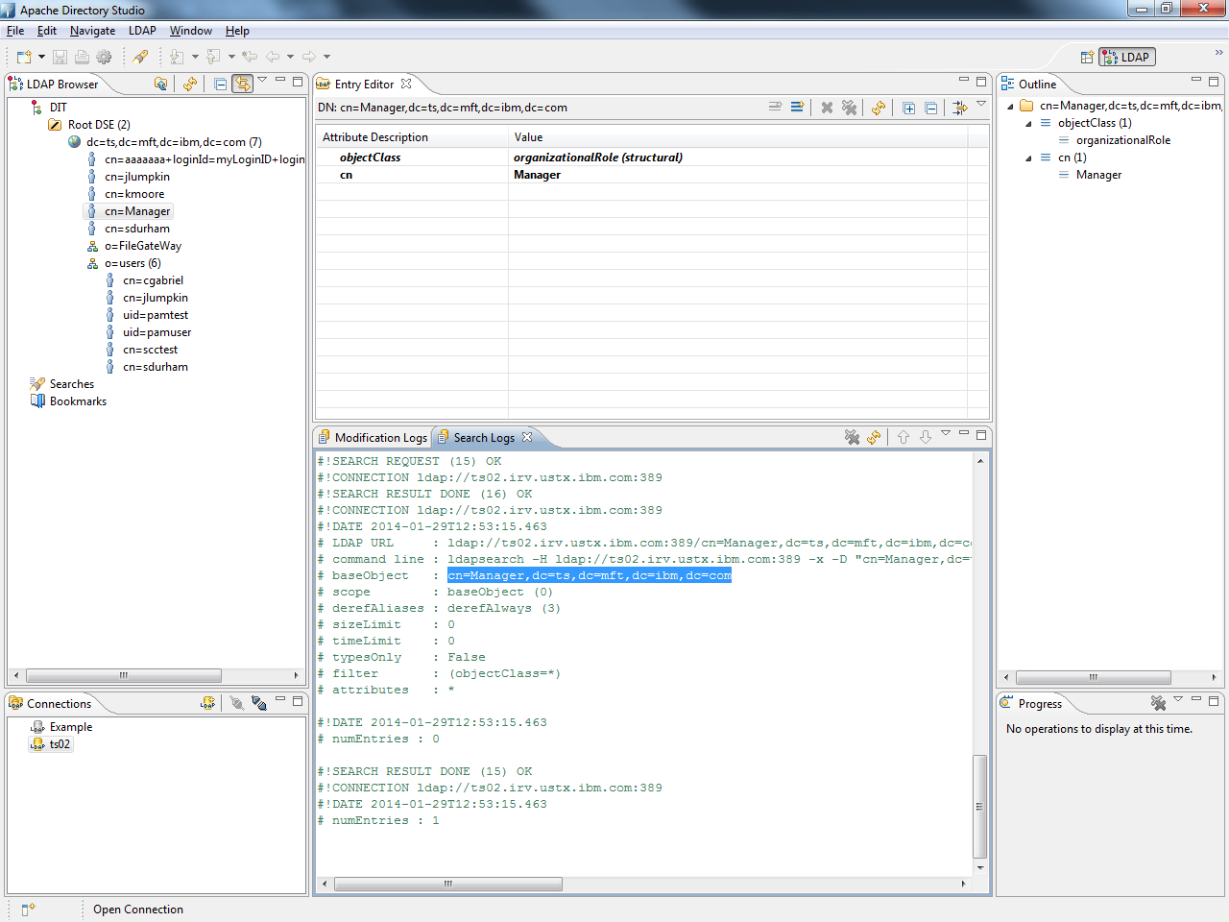

The base DN that we will be adding users to are in the examples to follow.

**o=users,dc=ts,dc=mft,dc=ibm,dc=com**

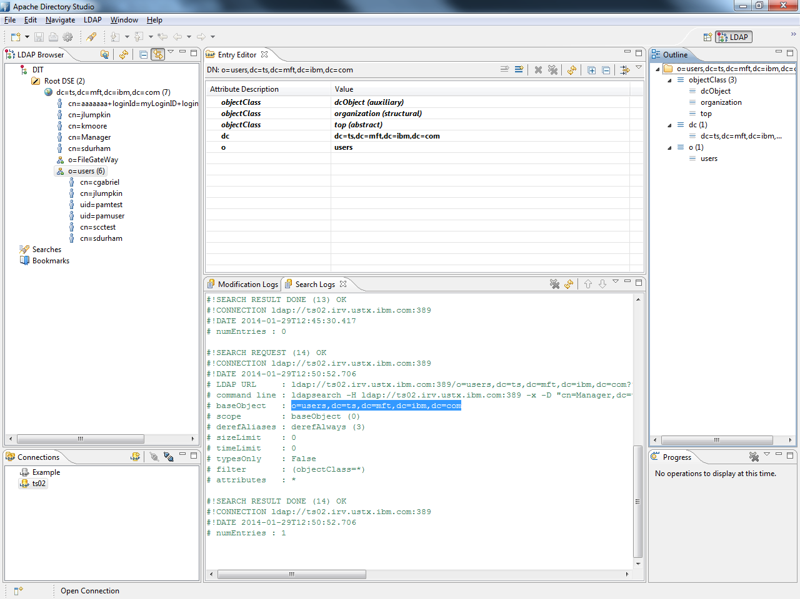

Log in as root on the client system that will be using pam to authenticate to OpenLDAP.

Note: The client system can be the same system where OpenLDAP is installed.

Make sure you have an X-Windows service running before bringing up the YaST Control Center!

[root@ironman] /home/cd4104 $ yast2

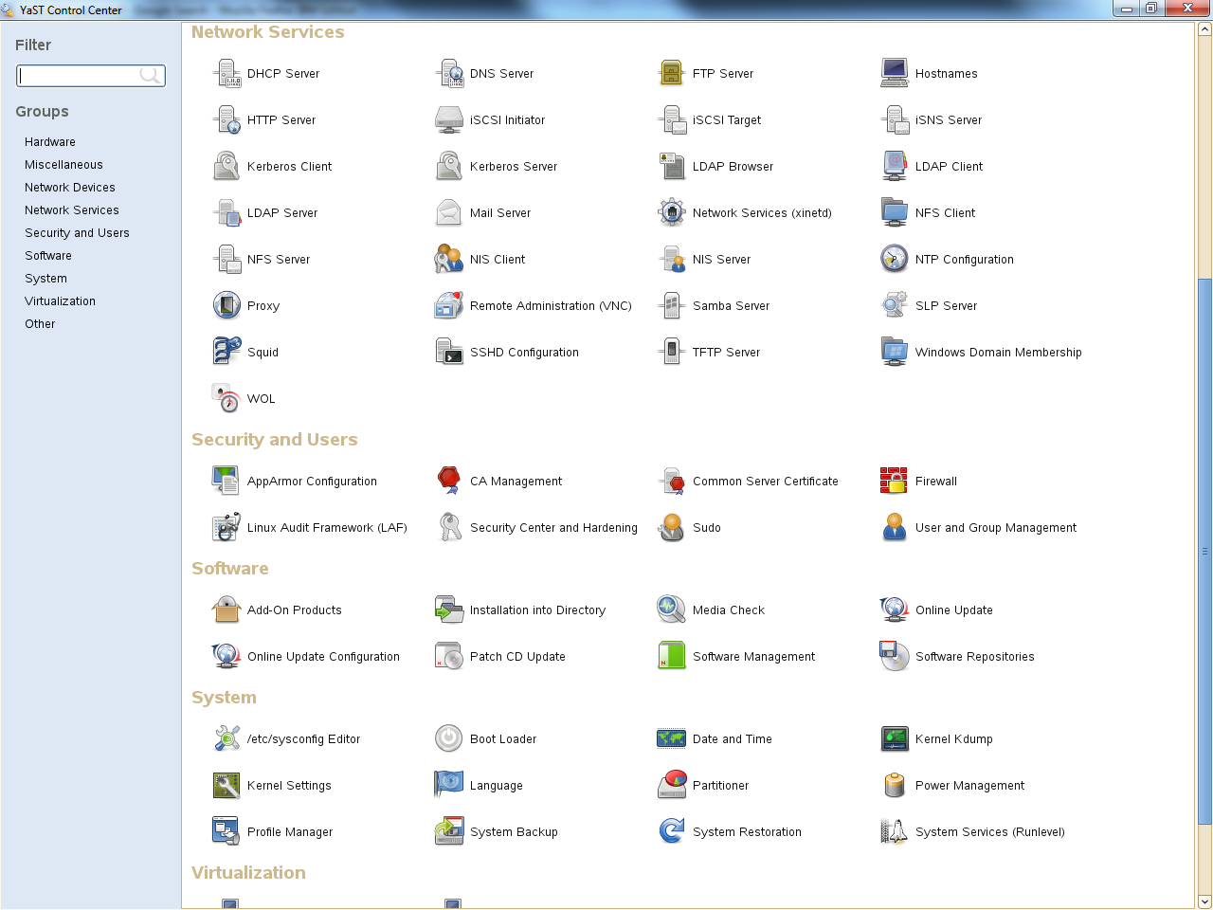

Click on **LDAP Client** Configuration under Network Services

Select **Use LDAP**, enter the IP or FQDN of the LDAP Server

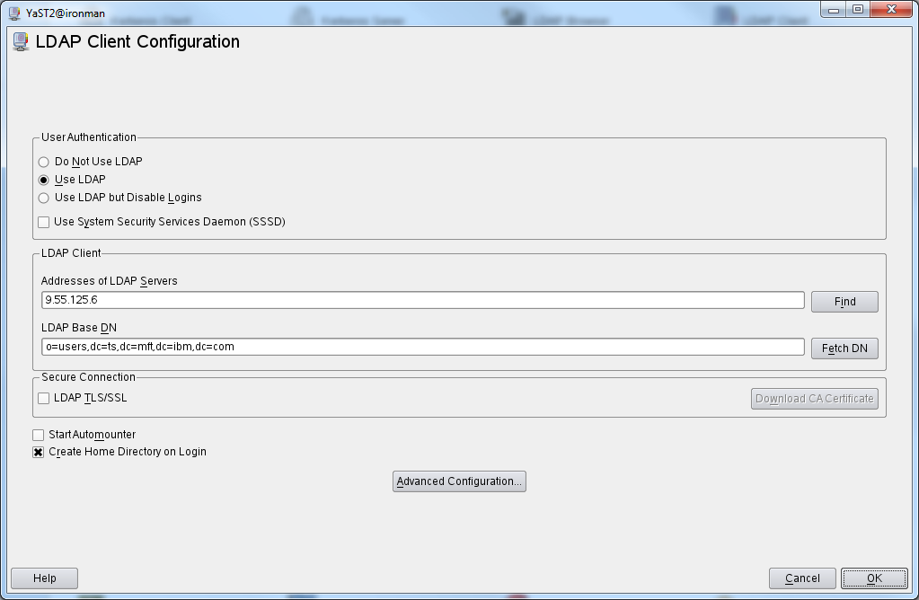

Click on **Fetch DN** and search down the LDAP tree until you find the base DN you want to use.

In this example we will be selecting **o=users,dc=ts,dc=mft,dc=ibm,dc=com**

**Click OK**

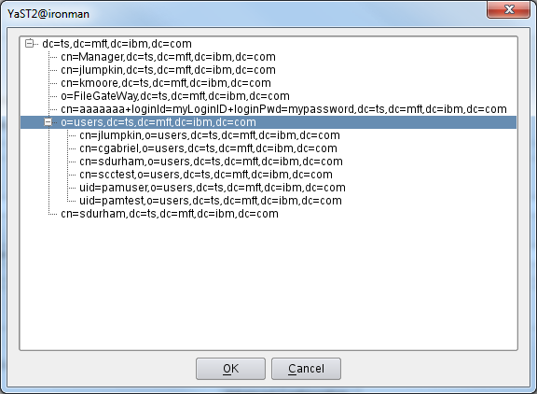

Select **Create Home Directory on Login**



Click on **Advanced Configuration** and verify that all three Maps contain the base DN as defined above. Note: This is the default setting

Select **clear** under Password Change Protocol

Select **member** under Group Member Attribute (default setting)

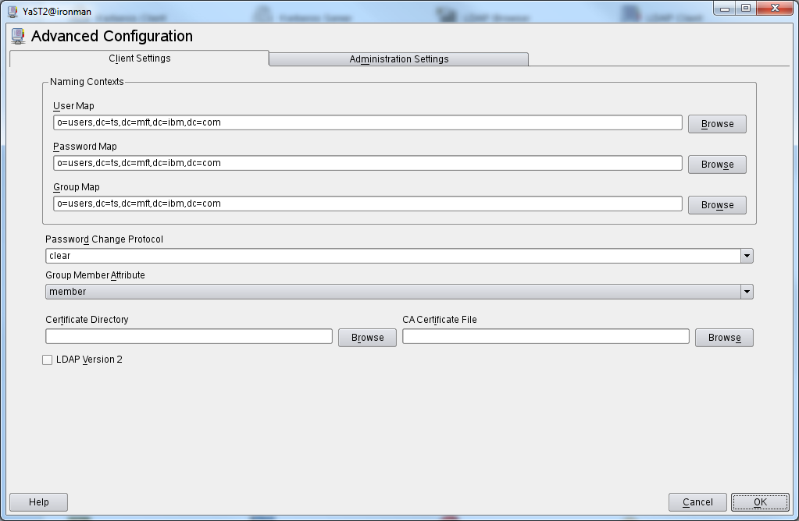

Select the Administration Settings tab and verify the Base DN is the same as above.

Enter the root base DN from the OpenLDAP Server, **cn=Manager,dc=ts,dc=mft,dc=ibm,dc=com** under **Administrator DN**

Click **OK** to save settings.

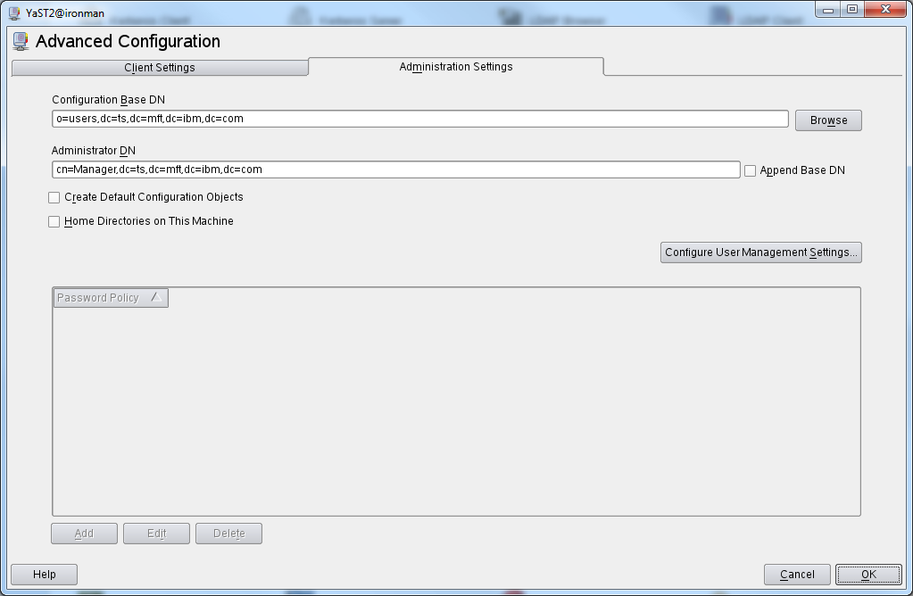

Click **OK** to save settings.



Click on **User and Group Management** under Security and Users

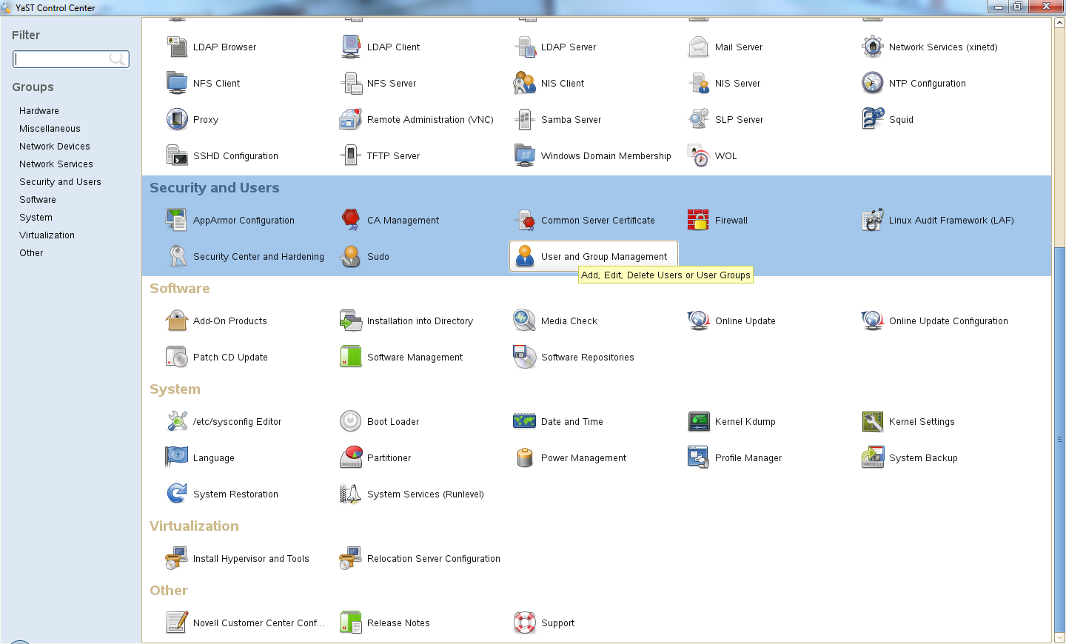

Click on the **Set Filter** drop down tab and select **LDAP Users**. Enterthe **LDAP Server Password**

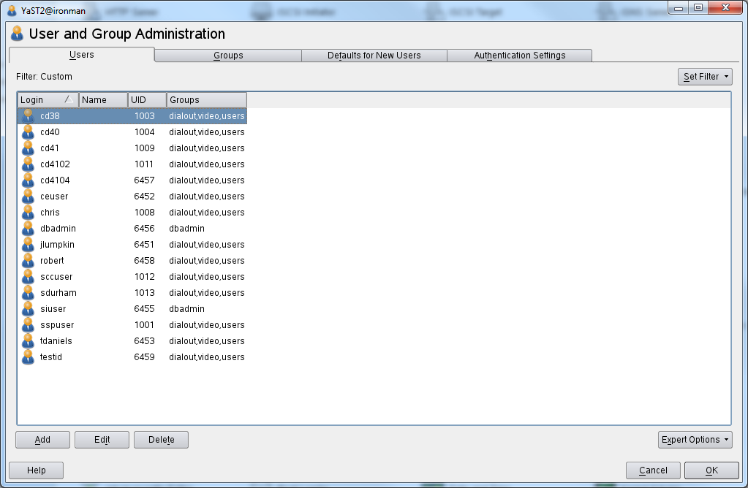

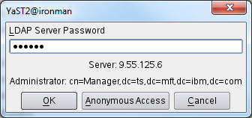

Only LDAP Users are now displayed.

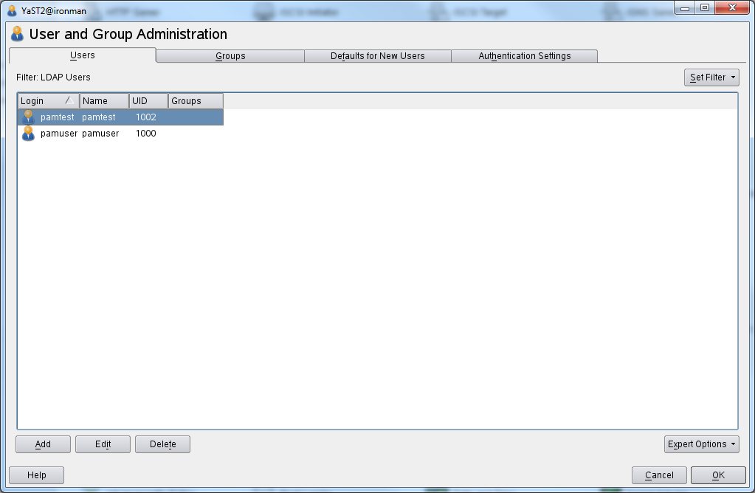

Click on **Add**, enter user data and password. Username is a combination of first and last name.

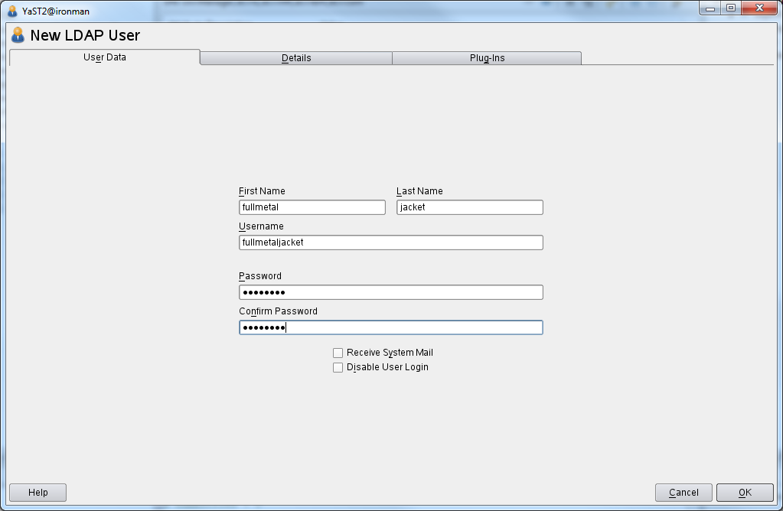

Click the **Details** tab to view user settings. Normally no changes needs to be made!

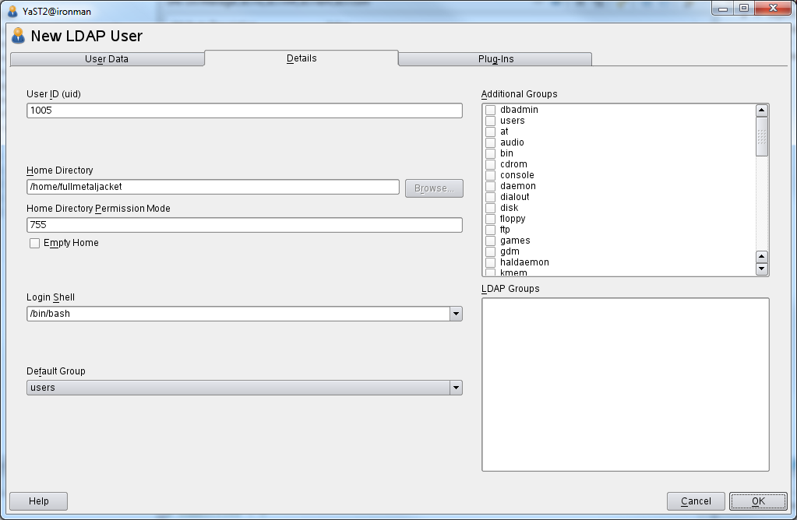

Click the **Plug-Ins** tab, and then click the **Launch** button to view Remaining LDAP Attributes.

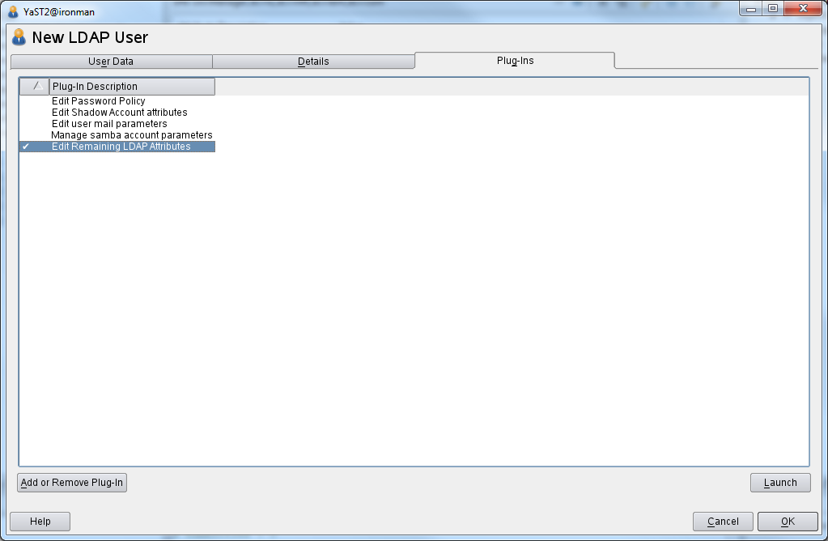

You can review default settings or click the **Edit** to make changes to each attribute if needed.

Click **OK** to return to User and Group Administration screen.

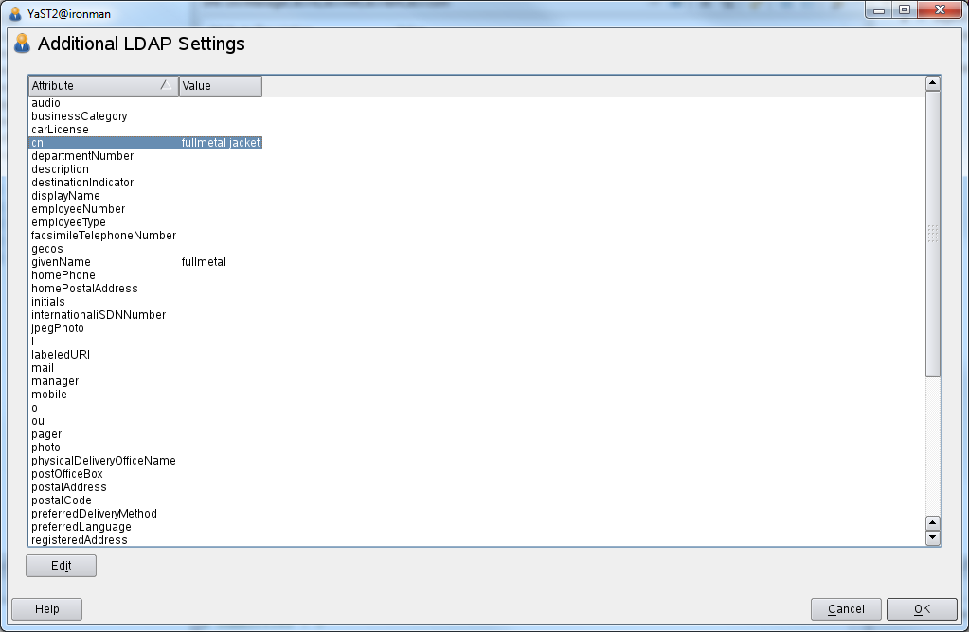

Click **OK** to save user data.

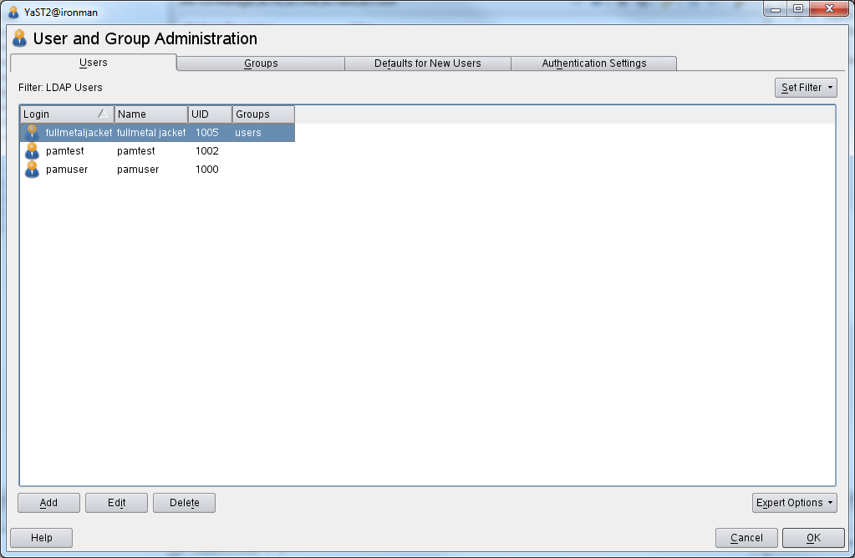

Refresh the LDAP tree to display the new user account. It may take up to 5 minutes before new user information is propagated to the LDAP Server.

**uid=fullmetaljacket,o=users,dc=ts,dc=mft,dc=ibm,dc=com**

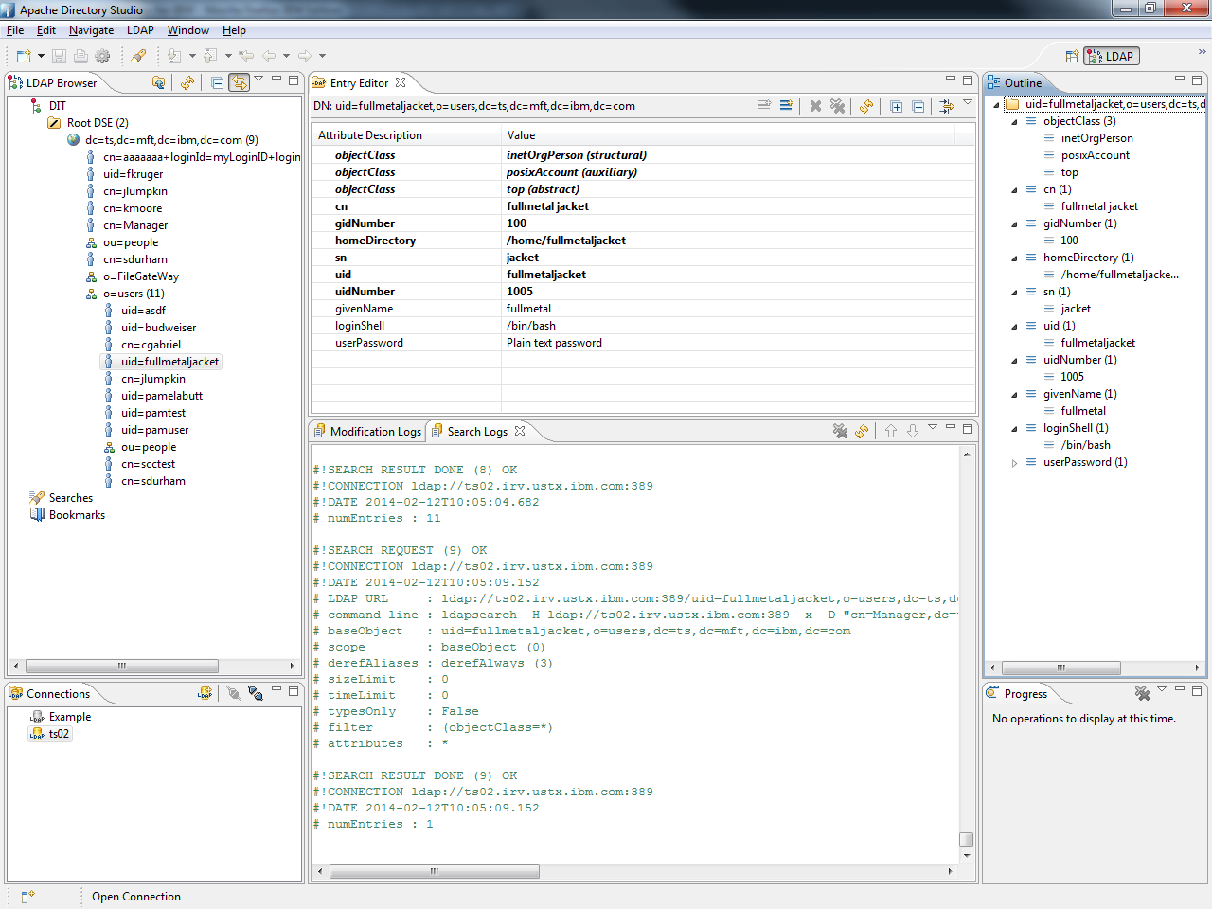

Verify you can log in with the new user id.

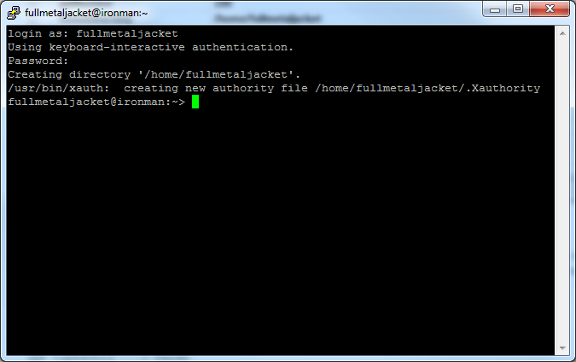

If you do a tail –f on /var/log/messages file you will see a successful login:

**Feb 4 12:23:56 ironman sshd[17719]: Accepted keyboard-interactive/pam for fullmetaljacket from 9.55.70.93 port 49602 ssh2**

**Apache Directory Studio LDAP Browser installation and setup procedure.**

Run the installation file. This example is on Windows: ApacheDirectoryStudio-win32-1.2.0.v20080818.exe

Click next.

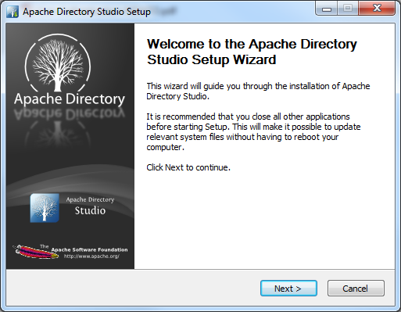

Click on **I Agree** for the License Agreement.

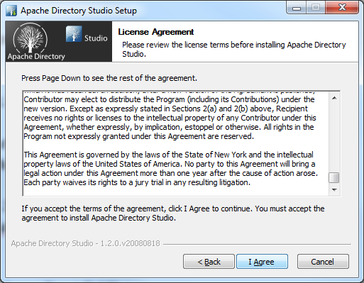

Click **Next** to take the default install.

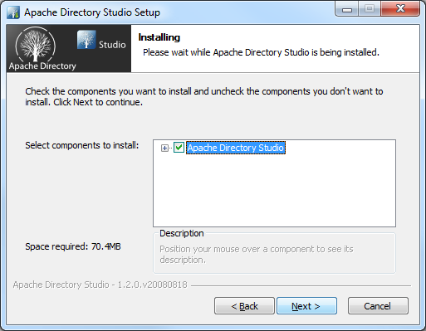

Click **Install** to install to the default directory.

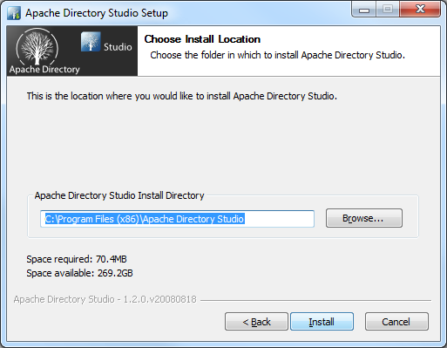

Click **Next**

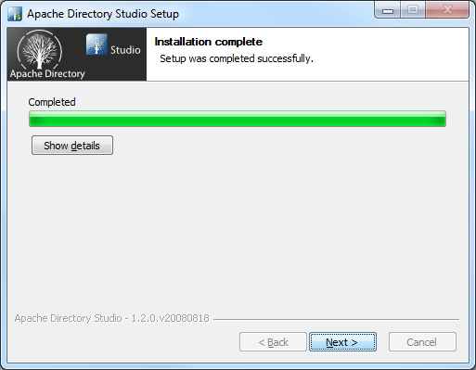

Click **Finish**

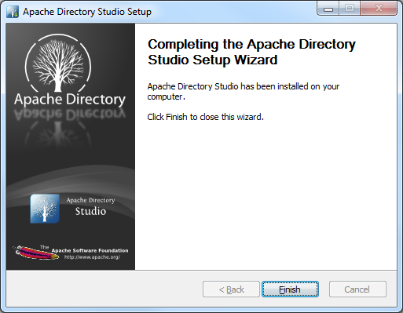

Enter the following information when you first start up the client.

**Apache Directory Studio Configuration Setup to OpenLDAP**

|  |
| --- |
| ***Connection name: ts02 Host name: ts02.irv.ustx.ibm.com Port: 389 Encryption Method: no encryption Provider: Apache Directory LDAP Client API  Authentication Method: Simple Bind DN or user: cn=Manager,dc=ts,dc=mft,dc=ibm,dc=com Bind Password: xxxxxx  Base DN:Get Base DNs from Root DSE*** |

Click on LDAP, then New Connection from top menu.

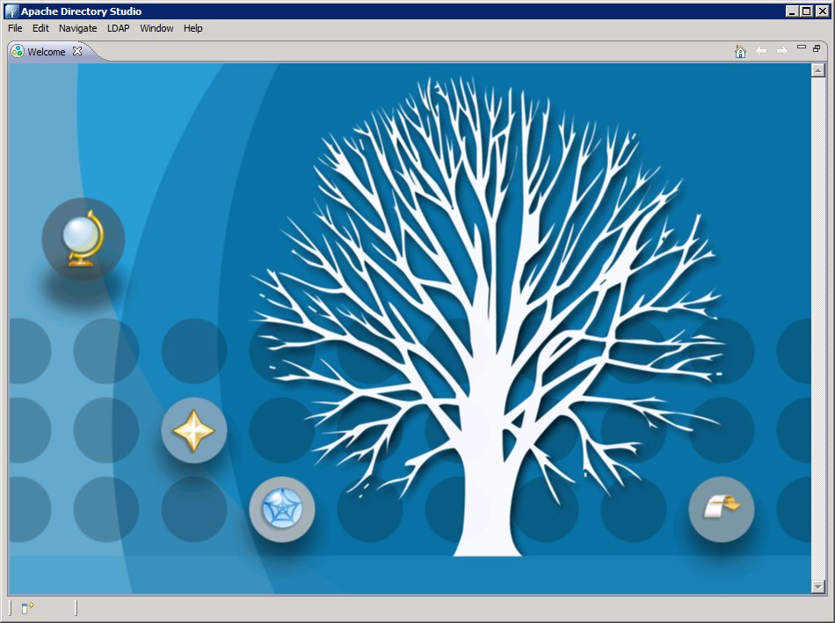

Enter the required Connection name and Network parameters.

Click Check Network Parameter to test the connection.

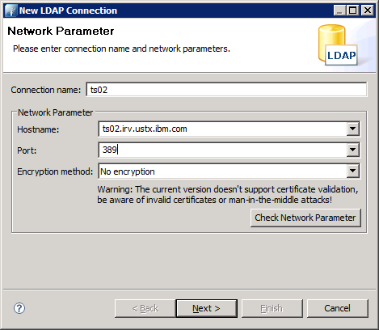

Click OK.

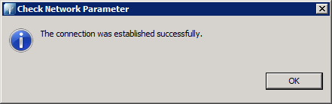

The Authentication window will open. Enter the required Authentication parameters.

Click Check Authentication to verify you are able to authenticate.

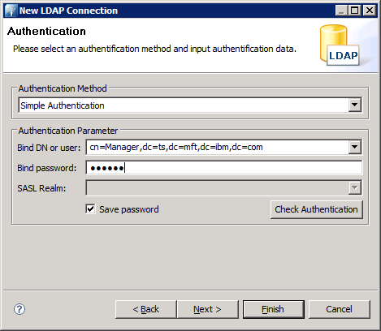

Click OK.

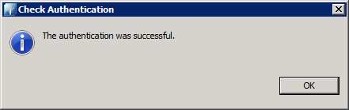

Click on Window, Show View, Connections from top menu or Click on the yellow Connections Icon located on the lower left hand corner.

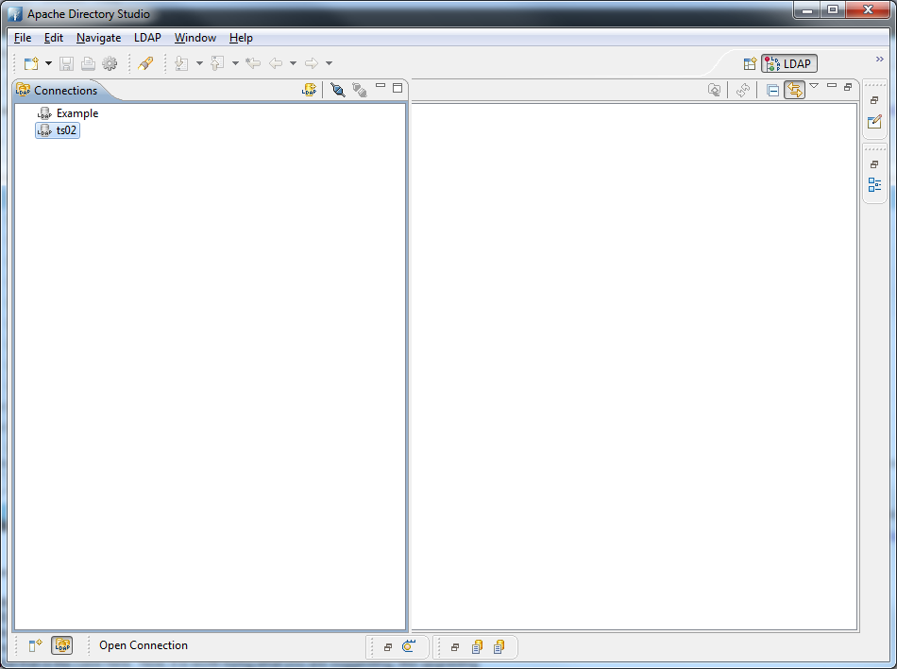

Highlight ts02 in the Connection panel and select the Open Connections icon.

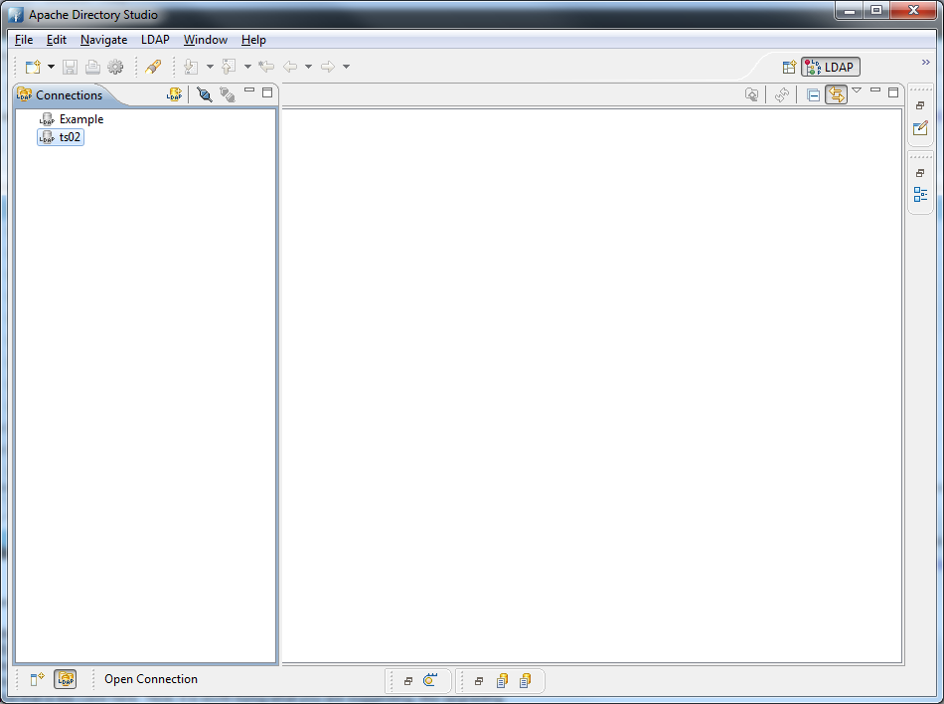

Click on Window, Show View, LDAP Browser.

Expand the tree until you find the account we created earlier.

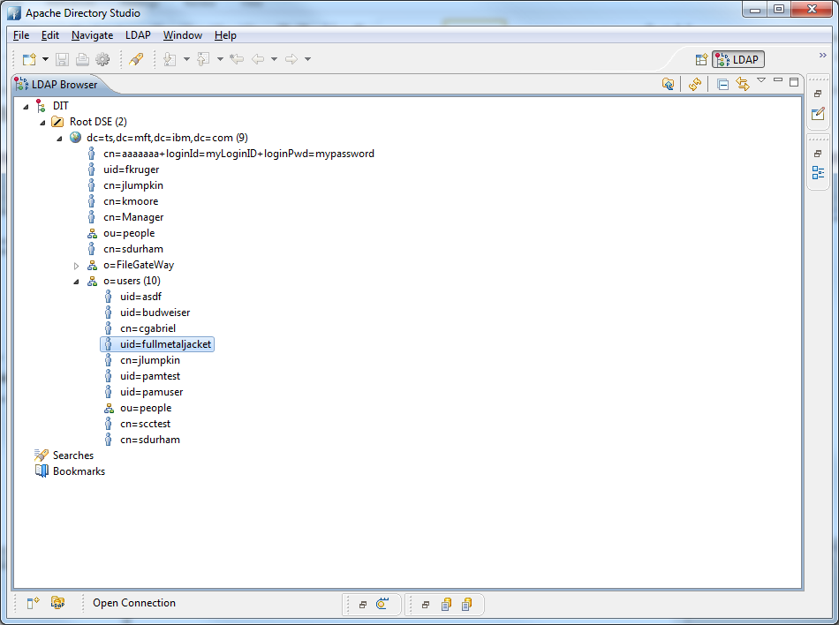

Click the Outline Icon to view user parameters.

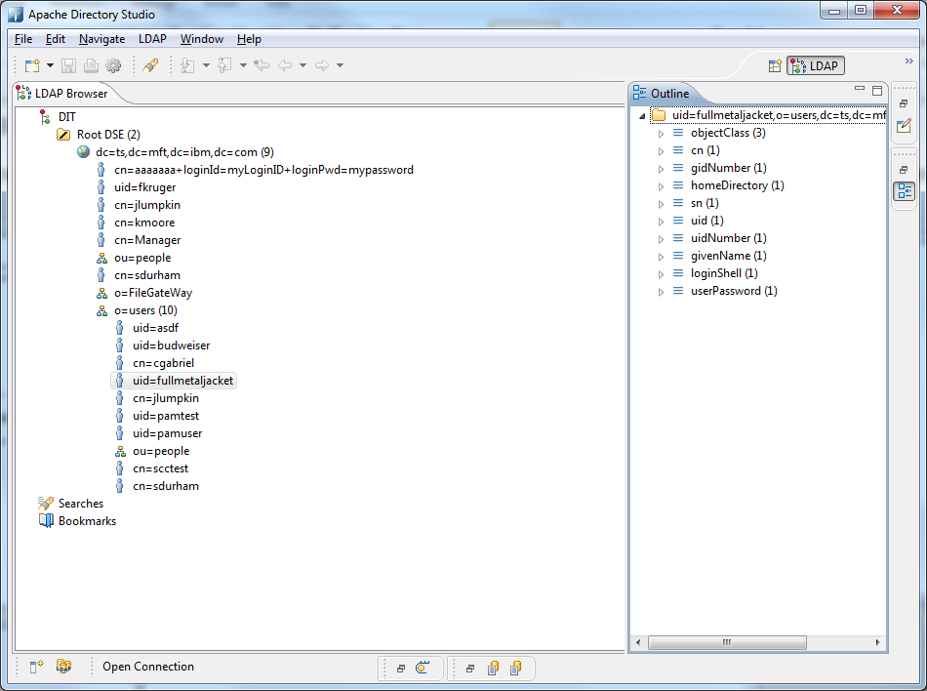

Click on Open Perspective Icon; select Schema Editor to make any changes.

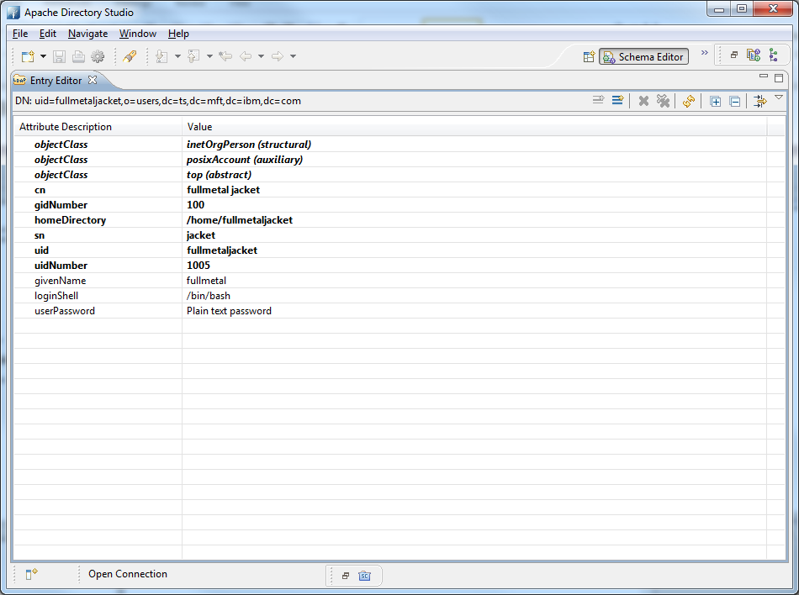

**Next we will configure C:D UNIX to use PAM.**

In my test, I attach to ironman using putty, then login as **cd4104**

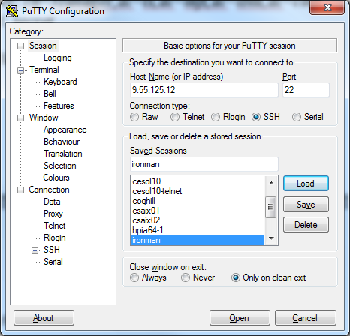

Edit the initparm.cfg file and add the service name to the ndm.pam:service parameter. The service name we will be using in our test is the default service name “**login**”, located in /etc/pam.d directory. Make sure to bounce the Connect:Direct application to apply the change.

[cd4104@ironman] /home/cd4104/ndm/cfg/ironman4104 $ **vi initparm.cfg**

# Miscellaneous Parameters

ndm.path:path=/home/cd4104:

ndm.node:name=ironman4104:

ndm.pam:service=**login**:

ndm.env_vars:sanitize=n:

Edit the userfile.cfg and add the two following records for the user account that was created.

[cd4104@ironman] /home/cd4104/ndm/cfg/ironman4104 $ **vi userfile.cfg**

fullmetaljacket:\

:admin.auth=y:\

:pstmt.copy.ulimit=y:\

:pstmt.upload=y:\

:pstmt.upload_dir=:\

:pstmt.download=y:\

:pstmt.download_dir=:\

:pstmt.run_dir=:\

:pstmt.submit_dir=:\

:name=:\

:phone=:\

:descrip=:

fullmetaljacket@ironman4104:\

:local.id=fullmetaljacket:\

:pstmt.upload=y:\

:pstmt.upload_dir=:\

:pstmt.download=y:\

:pstmt.download_dir=:\

:pstmt.run_dir=:\

:pstmt.submit_dir=:\

:descrip=:

To verify that Connect:Direct can authenticate using PAM to connect to LDAP make a copy of the loopback script sample.cd and add the snodeid of the user account and password that was created.

[cd4104@ironman] /home/cd4104/ndm/bin $ **cp sample.cd pamtest.cd**

[cd4104@ironman] /home/cd4104/ndm/bin $ **vi pamtest.cd**

/*

* This sample process copies a text file "msgfile.cfg"

* from "pnode" to "snode". Checkpoint interval is set to 2M

* and extended compression is used. The destination file

* "cddelete.me" is located in the HOME directory of the installer.

*/

sample process snode=ironman4104 **snodeid=(fullmetaljacket,xxxxxxxx)**

step01 copy

from

(

file = /home/cd4104/ndm/cfg/msgfile.cfg

pnode

)

ckpt = no

to

(

file = /home/cd4104/tmp/cddelete.me

snode

disp = rpl

)

pend;

**The messages file shows the ndmsmgr demon when the script ran.**

[root@ironman] /etc $ **tail -f /var/log/messages**

Mar 26 03:14:17 ironman ndmsmgr: pam_mail(login:session): pam_putenv: delete non-existent entry; MAIL

Bring up the Connect:Direct CLI, enable traces, execute the script, disable traces. In this example I will be using the following shell scripts to enable/disable the traces.

[cd41@ironman] /home/cd41/ndm/bin $ **cat traceon.sh**

direct << EOJ

trace pmgr;

trace cmgr;

trace comm;

trace smgr;

quit;

EOJ

[cd41@ironman] /home/cd41/ndm/bin $ **cat traceoff.sh**

direct << EOJ

trace pmgr level=0;

trace cmgr level=0;

trace comm level=0;

trace smgr level=0;

quit;

EOJ

[cd4104@ironman] /home/cd4104/ndm/bin $ **traceon.sh**

**************************************************************

* *

* Licensed Materials - Property of IBM *

* *

* IBM(R) Sterling Connect:Direct(R) for UNIX 4.1.0.4_iFix013 *

* Build date: 01Nov2013 *

* *

* (C) Copyright IBM Corp. 1992, 2013 All Rights Reserved. *

* *

**************************************************************

Enter a ';' at the end of a command to submit it. Type 'quit;' to exit CLI.

Direct> Command Submitted Successfully.

Direct> Command Submitted Successfully.

Direct> Command Submitted Successfully.

Direct> Command Submitted Successfully.

Direct>

Connect:Direct CLI Terminated...

[cd4104@ironman] /home/cd4104/ndm/bin $ **direct**

**************************************************************

* *

* Licensed Materials - Property of IBM *

* *

* IBM(R) Sterling Connect:Direct(R) for UNIX 4.1.0.4_iFix013 *

* Build date: 01Nov2013 *

* *

* (C) Copyright IBM Corp. 1992, 2013 All Rights Reserved. *

* *

**************************************************************

Enter a ';' at the end of a command to submit it. Type 'quit;' to exit CLI.

Direct> **sub file=pamtest.cd;**

Process Submitted, Process Number = 2116

Direct> **sel stat pnum=2116;**

===============================================================================

SELECT STATISTICS

===============================================================================

P RECID LOG TIME PNAME PNUMBER STEPNAME CCOD FDBK MSGID

E RECID LOG TIME MESSAGE TEXT

-------------------------------------------------------------------------------

E QCEX 02/04/2014 13:12:48 TCQ queue change from WAIT to EXEC, status PE.

E SSTR 02/04/2014 13:12:48 Session started, SNODE:ironman4104, Protocol:tcp

LCLP 9.55.125.12, PORT=43305

RMTP 9.55.125.12, PORT=1364

P PSTR 02/04/2014 13:12:48 sample 2116 0 XSMG200I

P PSTR 02/04/2014 13:12:48 sample 2116 0 XSMG200I

P RSST 02/04/2014 13:12:48 sample 2116 step01 0 XSMG201I

P LSST 02/04/2014 13:12:48 sample 2116 step01 0 XSMG201I

P CTRC 02/04/2014 13:12:52 sample 2116 step01 0 SCPA000I

P CTRC 02/04/2014 13:12:52 sample 2116 step01 0 SCPA000I

P PRED 02/04/2014 13:12:52 sample 2116 0 XSMG252I

E SEND 02/04/2014 13:12:52 Session ended, Session Manager shutting down SNODE:

ironman4104

P PRED 02/04/2014 13:12:52 sample 2116 0 XSMG252I

===============================================================================

Select Statistics Completed Successfully.

Direct> **q;**

Connect:Direct CLI Terminated...

[cd4104@ironman] /home/cd4104/ndm/bin $ **traceoff.sh**

**************************************************************

* *

* Licensed Materials - Property of IBM *

* *

* IBM(R) Sterling Connect:Direct(R) for UNIX 4.1.0.4_iFix013 *

* Build date: 01Nov2013 *

* *

* (C) Copyright IBM Corp. 1992, 2013 All Rights Reserved. *

* *

**************************************************************

Enter a ';' at the end of a command to submit it. Type 'quit;' to exit CLI.

Direct> Command Submitted Successfully.

Direct> Command Submitted Successfully.

Direct> Command Submitted Successfully.

Direct> Command Submitted Successfully.

Direct>

Connect:Direct CLI Terminated...

Open the SMGR.TRC file and verify that we authenticated with PAM.

[cd4104@ironman] /home/cd4104/work/ironman4104 $ **vi SMGR.TRC**

Search for the user id fullmetaljacket

PID=18084 02/04 13:12:48:761568 sdsc_chk_ndm_func entered.

=18084 ARG profile: 0x8340EE0

=18084 ARG which : 20

=18084 sdsc_chk_ndm_func exited (YES).

=18084 ****snode_id: **fullmetaljacket**

PID=18084 02/04 13:12:48:763539 COMM TRACE SEND

=18084 RH VALUE 0xba000000

=18084 RH DECODE REQUEST: CH=ONLY RESP=EXC CHG_DIR FMH

=18084

=18084 OFFSET BUFFER LENGTH = 268

=18084 00000000 4245474E 63687234 464D3732 464D4944 *BEGNchr4FM72FMID*

=18084 00000010 696E7431 00000072 434D4400 696E7431 *int1 rCMD int1*

=18084 00000020 00000001 56524C56 696E7431 00000020 * VRLVint1 *

=18084 00000030 4E53504E 74727565 5349444F 74727565 *NSPNtrueSIDOtrue*

=18084 00000040 50505249 696E7431 0000000A 504E414D *PPRIint1 PNAM*

=18084 00000050 73747200 00000006 73616D70 6C650000 *str sample *

=18084 00000060 50494400 73747200 00000008 20202020 *PID str *

=18084 00000070 32313136 444E4F44 73747200 0000000B *2116DNODstr *

=18084 00000080 69726F6E 6D616E34 31303400 4F4E4F44 *ironman4104 ONOD*

=18084 00000090 73747200 0000000B 69726F6E 6D616E34 *str ironman4*

=18084 000000a0 31303400 44554944 73747200 0000000F *104 DUIDstr *

=18084 000000b0 66756C6C 6D657461 6C6A6163 6B657400 \***fullmetaljacket** *

=18084 000000c0 444F5057 6F706171 00000008 2A2A2A2A *DOPWopaq *****

=18084 000000d0 2A2A2A2A 4F554944 73747200 00000006 *****OUIDstr *

=18084 000000e0 63643431 30340000 4F525057 6F706171 *cd4104 ORPWopaq*

=18084 000000f0 00000003 2A2A2A00 52430000 696E7434 * *** RC int4*

=18084 00000100 00000000 454E4400 766F6964 * END void *

PID=18085 02/04 13:12:48:763992 COMM TRACE RECEIVE

=18085 RH VALUE 0xba000000

=18085 RH DECODE REQUEST: CH=ONLY RESP=EXC CHG_DIR FMH

=18085

=18085 OFFSET BUFFER LENGTH = 268

=18085 00000000 4245474E 63687234 464D3732 464D4944 *BEGNchr4FM72FMID*

=18085 00000010 696E7431 00000072 434D4400 696E7431 *int1 rCMD int1*

=18085 00000020 00000001 56524C56 696E7431 00000020 * VRLVint1 *

=18085 00000030 4E53504E 74727565 5349444F 74727565 *NSPNtrueSIDOtrue*

=18085 00000040 50505249 696E7431 0000000A 504E414D *PPRIint1 PNAM*

=18085 00000050 73747200 00000006 73616D70 6C650000 *str sample *

=18085 00000060 50494400 73747200 00000008 20202020 *PID str *

=18085 00000070 32313136 444E4F44 73747200 0000000B *2116DNODstr *

=18085 00000080 69726F6E 6D616E34 31303400 4F4E4F44 *ironman4104 ONOD*

=18085 00000090 73747200 0000000B 69726F6E 6D616E34 *str ironman4*

=18085 000000a0 31303400 44554944 73747200 0000000F *104 DUIDstr *

=18085 000000b0 66756C6C 6D657461 6C6A6163 6B657400 \***fullmetaljacket** *

=18085 000000c0 444F5057 6F706171 00000008 2A2A2A2A *DOPWopaq *****

=18085 000000d0 2A2A2A2A 4F554944 73747200 00000006 *****OUIDstr *

=18085 000000e0 63643431 30340000 4F525057 6F706171 *cd4104 ORPWopaq*

=18085 000000f0 00000003 2A2A2A00 52430000 696E7434 * *** RC int4*

=18085 00000100 00000000 454E4400 766F6964 * END void *

PID=18085 02/04 13:12:48:779732 sdsc_create entered.

=18085 ARG error : 0x82C8510

=18085 ARG usr_name : **fullmetaljacket**

=18085 ARG node_name : ironman4104

=18085 ARG init_parms : 0x82C8528

=18085 ARG local_node : ironman4104

=18085 ARG usr_profile : 0x8304C48

=18085 ARG submitter_id :

=18085 ARG altUserFileName :

PID=18085 02/04 13:12:48:779844 -> sdcf_fileread

=18085 cfh: 0x082FF200

=18085 buffer: 0xFFE685D0

=18085 key: **fullmetaljacket**

=18085 <- sdcf_fileread: found **fullmetaljacket**

=18085 <- sdcf_read: record ok